***Tracking Waste Disposal and Generation of Fine to control and promote proper waste segregation***

Prof. Ashok K N

Assistant Professor

Department of Computer Science and Engineering

S J C Institute of Technology Chikballapur, India

ashokkn@sjcit.ac.in

Ms. Nagashree C R

Student

Department of Computer Science and Engineering

S J C Institute of Technology Chikballapur, India

crnagashree8@gmail.com

Ms. Kavyashree K S

Student

Department of Computer Science and Engineering

S J C Institute of Technology Chikballapur, India

kavyaks793@gmail.com

Ms. Navya L

Student Department of Computer Science  
and EngineeringS J C Institute of TechnologyChickballapur, India  
navyalakshman7899@gmail.com Ms. Keerthana S

Student

Department of Computer Science and Engineering

S J C Institute of Technology Chikballapur, India [Keerthana11567@gmail.com](mailto:Keerthana11567@gmail.com)

***Abstract—*** *Approximately 10 million tonnes of waste is produced by metropolitan cities alone in India. The waste materials which are left untreated will definitely cause various types pollution like water, soil and air which completely damage the ecosystem.* *When people are sensitive to waste segregation at individual level this maniac can be avoided. Many policies have failed to achieve this objective because of lack of awareness and poor enforcement of rules and regulations by authorities during collection of segregated waste at household level. So, our intention is to track and impose fine when they don't follow the rules and regulations in segregation at household level. The aim of this project is to use webcam images for analyzing the percentage of non-segregation of biodegradable and non-biodegradable waste while it’s been dumped during collection of waste by authorities and apply fines according to the incorrect disposal of waste. One innovative approach to analyze the percentage of non-Segregated waste is through using Convolution Neural Networks (CNN) algorithm of deep learning. This innovative system promotes responsible waste disposal practices, contributing to a cleaner and more sustainable environment.*

***Keywords—*** *Waste segregation, Biodegradable and Non-Biodegradable, CNN (Convolutional Neural Networks),* *Deep learning,* *Sustainable environment,* *Enforcement, Fine Generation, Individual Awareness*.

1. INTRODUCTION

India generates approximately 1,33,760 tonnes of Municipal Solid Waste per day, of which approximately 91,152 tonnes is collected and approximately 25,884 tonnes is treated. MSW generation per capita in India ranges from approximately 0.17 kg per person per day in small towns to approximately 0.62 kg per person per day in cities. Despite significant development in social, economic and environmental areas, Solid Waste Management systems in India have remained relatively unchanged. The informal sector has a key role in extracting value from waste, with approximately 90% of residual waste currently dumped rather than properly landfilled. Waste generation in urban areas of India will be 0.7 kg per person per day in 2025, approximately four to six times higher than in 1999. Solid Waste Management disposal is at a critical stage of development in India. There is a need to develop facilities to treat and dispose of increasing amounts of Municipal Solid Waste. More than 90% of waste in India is believed to be dumped in an unsatisfactory manner. It is estimated that approximately 1400 Km2 was occupied by waste dumps in 1997 and this is expected to increase in the future. Waste dumps have adverse impacts on the environment and public health. Open dumps release methane from decomposition of biodegradable waste under anaerobic conditions. Methane causes fires and explosions and is a major contributor to global warming. There is no proper segregation of the waste at the household level Because Residents in India also throw garbage improperly due to a lack of cooperation among a few citizens and the absence of planned settlements. The adverse environmental impact of wrong Solid Waste Management is due to incomplete collection, wrong design, operation or maintenance of landfill due to this practice there may be adverse effects like Air Borne and Water Born Disease, Increase in Greenhouse Emission and Other air Pollution, Contamination of Ground and Surface Water, Adverse effect on ecosystems.

# **LITERATURE REVIEW**

Ms. R. Pushpakalambiga and Prof. Dr. J. Jasmine proposed a paper Biodegradable and Non-Biodegradable waste management focuses on the management of biodegradable and non-biodegradable waste in India. It highlights the environmental problems caused by plastic waste and household waste, which are major sources of pollution. The paper emphasizes the importance of proper waste disposal and the need for awareness and education among individuals. The three R’s - Recycle, Reuse, and Reduce - are suggested as simple steps that can be taken to contribute to waste management and environmental conservation.

Ipek Atik propped a paper Analysis of Biodegradable and Non-Biodegradable materials using selected Deep Learning Algorithm. The study aims to effectively classify waste materials in order to identify, track, sort, and process them. Biodegradable materials can naturally decompose and be processed into compost, while non-biodegradable materials do not naturally degrade and can only be reused by converting them into new materials. The study uses different deep learning algorithms such as AlexNet, ShuffleNet, SqueezeNet, and GoogleNet to classify images of biodegradable and non-biodegradable materials. A dataset consisting of 5430 images, including 2794 biodegradable images and 2634 non-biodegradable images, is used for training, validation, and testing. The performance of the algorithms is evaluated using metrics such as error rate, precision, sensitivity, and F-measure. The results show that Shuffle Net achieves the highest classification accuracy of 98.73%. The proposed study demonstrates higher success rates compared to previous studies in classifying materials. The findings of this study contribute to the effective separation and processing of waste materials, which can have a positive impact on the environment and economy.

Arghadeep Mitra proposed paper Detection of waste materials using Deep Learning and Image Processing. The project focuses on waste management and proposes the use of object detection software for waste classification and identification. The document mentions the use of the Faster R-CNN model for detecting multiple objects in an image, as it has a higher accuracy rate compared to other deep learning models. The methodology used in the project is briefly explained, and the document concludes with experimental results and future work.

Menaka S proposed the paper Machine Learning approach for Prediction and Separation of Biodegradable and Non-Biodegradable waste. The research proposes a physical approach using a Deep Learning structure for waste segregation, aiming to address the challenges of waste identification and removal. The study utilizes the Improved Faster Recurrent Convolutional Neural Network (IFRCNN) to develop an intelligent smart bin system that can accurately classify waste into biodegradable and non-biodegradable categories. The proposed method achieves a precision ranging from 96.23% to 98.15%, making it more accurate than the current state-of-the-art technology. Additionally, the paper evaluates different deep learning models, including VGG-16, InceptionNet, ResNet, and AlexNet, to train and assess the performance of the proposed approach.

Haruna Abdu and Mohd Halim Mohd Noor proposed paper A Survey on Waste Detection and Classification Using Deep Learning. They discuss the growing concern of waste management globally and the need for early waste detection and sorting to maximize recycling and reduce environmental contamination. The authors review various deep learning models, such as AlexNet, VGG16, Inception-ResNet, MobileNet, and Deep Residual Networks, and explore their applications in waste detection and classification. They also compile over twenty benchmarked trash datasets to provide researchers with a solid background in this field. The paper highlights the challenges faced by existing methods and discusses the potential future of deep learning in waste management

1. **METHOLODOGY**

The aim of our project is to develop an image classification system that accurately determines the percentages of biodegradable and non-biodegradable waste from pre-segregated waste images and impose fines for incorrect disposal contributing to efficient waste management and environmental sustainability.

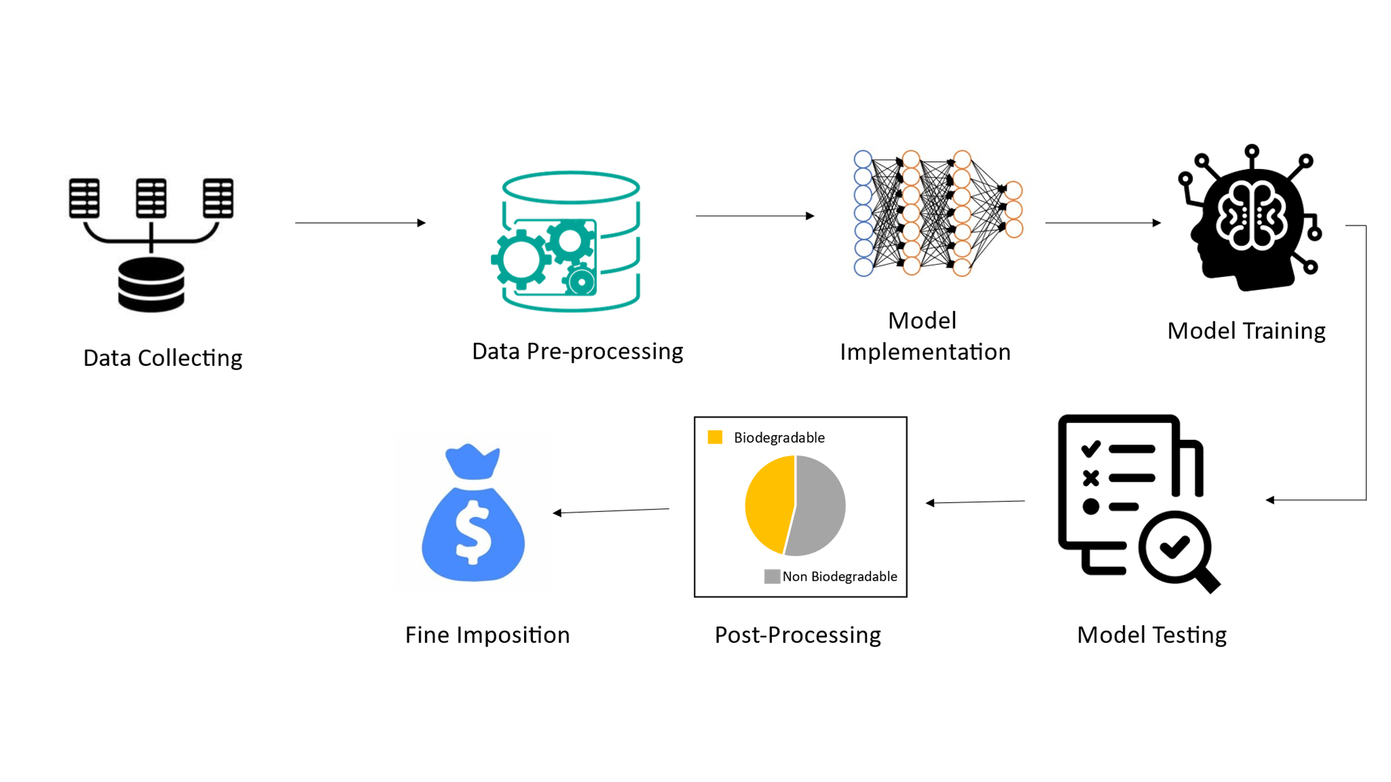

Fig.1. Work flow Diagram

The overall methodology is described in the following sub-sections:

1. Dataset Collection
2. Dataset Preprocessing
3. Model Implementation
4. Training and Testing
5. Post-processing
6. Fine Imposition

Each of these sub-sections is described below:

1. Data Collection

The dataset is accessible on Kaggle and encompasses approximately 256,000 images (including 156,000 original data). It is organized into two fundamental classes: Biodegradable and Non-biodegradable.

Biodegradable: This class comprises materials naturally decomposable by microorganisms, including food, plants, and fruits. Waste from this category is suitable for composting.

Non-biodegradable: Encompassing materials resistant to natural decomposition, such as plastics, metals, and inorganic elements. Waste from this class is subject to recycling for the creation of new materials.

The images within the dataset are in JPG or JPEG format, maintaining a total size of 2GB. Each image has a consistent dimension of 200×200 pixels. Rayhan Zamzamy owns and collaborates on data extension and maintenance efforts for this valuable resource.

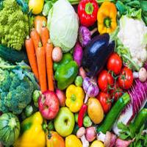  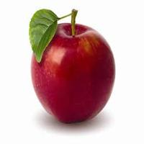

  

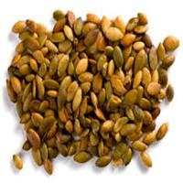  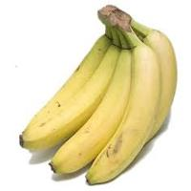

Food Plants Fruits

Fig.2. Sample Image From Biodegradable dataset

|  |  |
| --- | --- |
| Class | Details |
| Food | Vegetables,egg ,Meat  Bread and grains |
| Plants | Leaves, Branches,  flowers and wood |
| Fruits | Apple,banana, Watermelon,  pappaya |

Table.1. Details of Biodegradable dataset

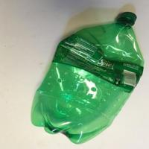 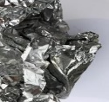 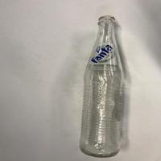

  

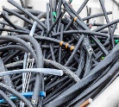 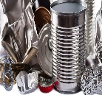 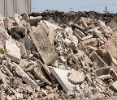

Plastic Metal Others

Fig.3. Sample Image From Non-Biodegradable dataset

|  |  |
| --- | --- |
| Class | Details |
| Plastic | Plasticbottle, pipes and  Electrical Cables |
| Metals | Aluminium, Steel and  Copper |
| Others | Glass , Ceramics and  Concrete |

Table.2. Details of Non-Biodegradable dataset

1. Dataset Preprocessing

In the data preprocessing step, augmented data is introduced to address imbalances within classes. This augmentation involves manipulating original data through transformations such as horizontal flip, vertical flip, 90-degree clockwise rotation, and 90-degree counterclockwise rotation.

1. Model Implementation

The model implementation for our project employs a deep learning architecture, specifically, CNN This deep learning model is designed with multiple layers, each serving a unique role in learning intricate features from input images during training. The process mimics the human brain's information processing, where different layers of neurons collaborate to recognize patterns. In our case, one-layer handles inputs, such as images, while hidden layers process the information, and the final layer produces predictions – in our context, whether the images contain biodegradable or non-biodegradable waste materials.

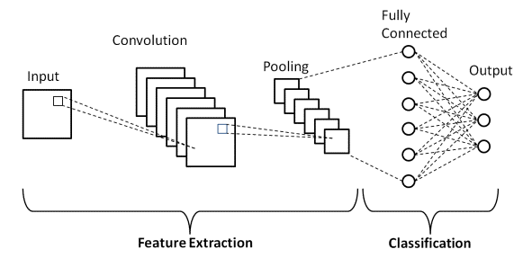

Fig.4. Basic Architecture of CNN

CNNs consist of multiple layers, each with a specific function. The main layers in a CNN are the convolutional layer, pooling layer, and fully connected layer. These layers work together to extract features from the input data and make predictions.

*1.Convolutional Layer:* This layer performs the convolution operation, which is a fundamental operation in CNNs. It consists of a set of learnable filters (kernels) that slide across the input volume, computing dot products between the filter and the input at each position. The resulting outputs are called feature maps, which represent the responses of the filter at different spatial positions. The depth, stride, and padding are hyperparameters that determine the characteristics of the output volume.

The output size is calculated in the following way:

(n + 2p – f) / s + 1

Where n is the number of filters, p is the amount of padding, f is the filter size and s is the stride

*2.Pooling Layer:* After convolutional layers, pooling layers are often used to reduce the dimensionality of the feature maps. The most common pooling operation is max pooling, where the maximum value within a region is selected. Average pooling is another option, where the average value is taken. Pooling layers help to extract the most important features while reducing the computational complexity.

*3.Fully-Connected Layer:* After several convolutional and pooling layers, the CNN typically ends with fully-connected layers. These layers transform the output tensor into a vector and apply neural network layers. The final fully-connected layer contains the same number of output neurons as the number of classes to be recognized. Techniques like dropout can be applied to prevent overfitting.

1. Training And Testing

The testing process follows a systematic approach. After training the Convolutional Neural Network (CNN) on a diverse dataset that includes both biodegradable and non-biodegradable waste images, we allocate a separate set of images specifically for testing purposes. These images, not seen by the model during training, are used to evaluate the model's ability to generalize its learned features to new, unseen data.

During testing, each image is input into the trained model, and the model generates predictions regarding whether the waste is biodegradable or non-biodegradable. The accuracy of these predictions is then compared against the ground truth labels for the testing set. This comparison allows us to measure key performance metrics, such as accuracy, precision, recall, and F1 score, providing a comprehensive assessment of the model's effectiveness in correctly classifying waste materials. The testing process ensures that the model performs reliably on diverse and previously unseen waste images, validating its practical utility for waste classification purposes.

1. *Accuracy (ACC):*

Accuracy represents the ratio of correctly classified instances to the total instances.

TP+TN

ACC =

TP+TN+FP+FN

where TP is True Positives, TN is True Negatives, FP is False Positives, and FN is False Negatives.

1. *Precision (P):*

Precision measures the accuracy of positive predictions.

TP

P =

TP +FP

1. *Recall (R) or Sensitivity:*

Recall assesses the model's ability to capture all relevant instances.

TP

R =

TP+FN

*4. F1 Score:*

The F1 Score is the harmonic mean of precision and recall, providing a balance.

2* Precision* Recall

F1 =

Precision +Recall

E . Post-processing

In the post-processing phase, we prioritize refining the model's output to ensure coherent and reliable predictions. This step addresses anomalies or uncertainties in the classification results, enhancing the model's overall accuracy. Specifically, during percentage analysis, we meticulously examine the calculated percentages of biodegradable and non-biodegradable waste. Any inconsistencies are rectified to provide users with precise and trustworthy insights. The refined results, including the accurate percentages, are then prominently displayed for user interpretation, fostering transparency and understanding of the model's performance in distinguishing between waste categories. This post-processing stage is pivotal in delivering meaningful and reliable classification outcomes.

F. Fine Imposition

For fine imposition, Initially a threshold percentage of 5% is set. If the model predicts that the percentage of non-biodegradable waste exceeds this threshold, a fine is imposed. The fine amount is calculated by multiplying the percentage of misclassified non-biodegradable waste by a fine rate of 2 rupees per percentage point. This means for every percentage point above the threshold, a fine of 2 rupees is applied. If the calculated fine amount is greater than zero, it is displayed as "Fine imposed." Otherwise, if the percentage is below the threshold, it indicates "No fine imposed." This mechanism encourages accurate waste classification and penalizes misclassifications beyond the specified threshold.

Fine Amount = Percentage of Misclassified Non-Biodegradable Waste * Fine Rate

**RESULTS AND ANALYSIS**

The main aim of the project is to segregate biodegradable and non-biodegradable waste from the main source of production, which is our society, prioritizing household waste. Controlling waste in society is crucial for preserving our environment and resources.hence investing in waste management infrastructure and encouraging proper disposal methods can help mitigate the negative impacts of waste on ecosystems and human health. these efforts contribute to a more sustainable future for generations to come.

Considering the image as an input the project model provides the fine ammount as the output for the user.

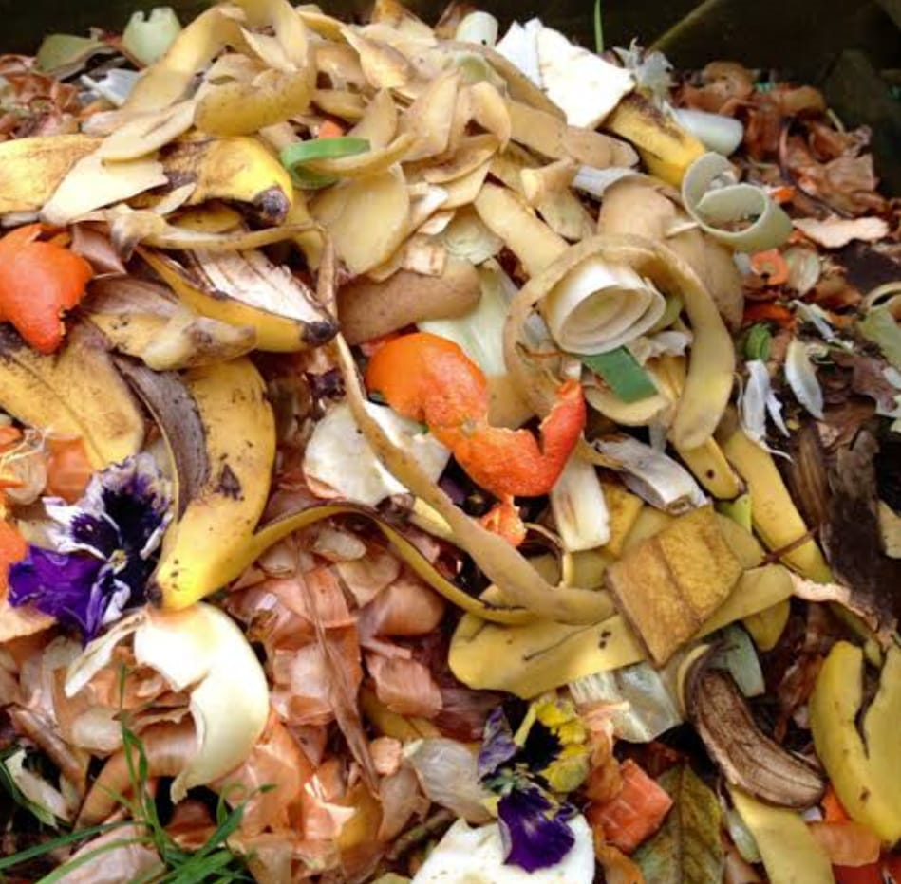

Fig.5. System input image 1

The percentage of non biodegradable is less than threshold percentage hence In output console we can observe no fine is imposed.

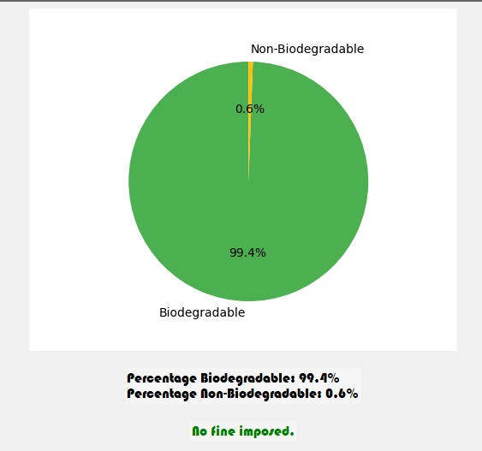

Fig.6. System output image 2

Then changing the feed given to the model with the below given image

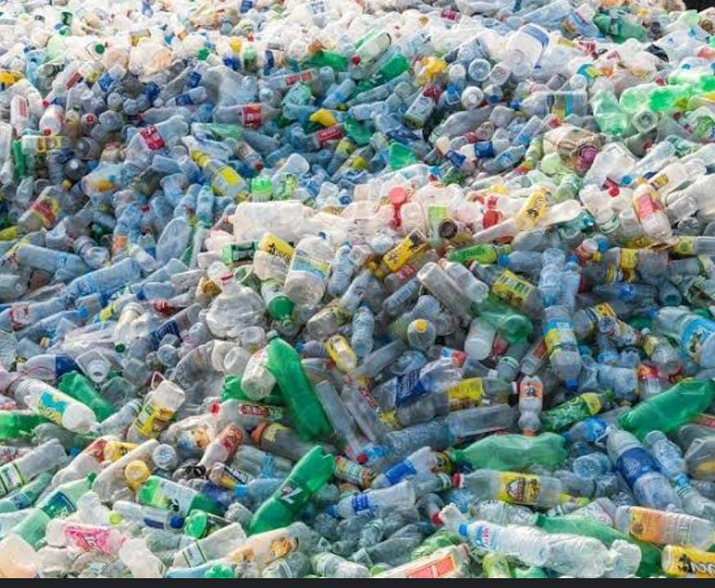

Fig.7. System input image 2

The percentage of non biodegradable waste is more then threshold leading to impossion of fine to user

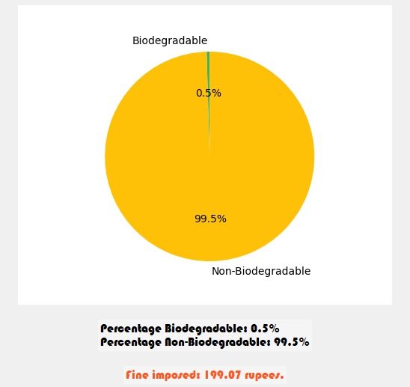

Fig.8. System output image 2

By imposing fines encourages users to make less hazard to society and environment

1. **CONCLUSION**

In this work it employs a comprehensive approach to tackle India's mounting waste management challenges. Users capture images of pre-segregated waste during disposal, and a sophisticated algorithm, built on a Deep Learning Framework like TensorFlow or Keras using Python, processes these images. Leveraging image processing libraries such as OpenCV, the system precisely assesses the percentage of biodegradable and non-biodegradable materials. A contamination threshold is established to identify misclassified waste, triggering fines through an intuitive interface designed for easy monitoring and management using tools like Matplotlib or Tkinter. By seamlessly integrating technology into waste sorting, The Project not only enhances accuracy but also promotes user awareness and accountability. Through efficient fine generation, the system incentivizes proper waste disposal, ultimately contributing to a cleaner and more sustainable environment. This innovative solution addresses the critical issues of incomplete waste collection, mismanagement, and adverse environmental impacts, fostering a positive change in waste management practices.

**REFERENCES**

[1] Ms. R. Pushpakalambiga and Prof. Dr. J. Jasmine proposed a paper Biodegradable and Non Biodegradable waste management

[2]Ipek Atik propped a paper Analysis of Biodegradable and Non Biodegradable materials using selected Deep Learning Algorithm

[3]Arghadeep Mitra proposed paper Detection of waste materials using Deep Learning And Image Processing .

[4]Menaka S proposed the paper Machine Learning approach for Prediction and Separation of Biodegradable and Non Biodegradable waste.

[5] Haruna Abdu and Mohd Halim Mohd Noor proposed paper A Survey on Waste Detection And Classification Using Deep Learning.

[6]https://www.scribd.com/document/576465576/Deep-Learning-based-Smart-Garbage-Classifier-for-Effective-Waste-Management

[7]Anunay A Gour and S.k Singh's "solid waste management in India: A state of the Art Review" Dept of Environmental Engineering, Delhi: (2022)

[8]Sedarth R, Rohit P vishagank,Karthika R,ganesan N" Deep learning based smart garbage classifier for Effective waste management" Dept of ECE, Amrita school of engineering , coimbatore (2020).